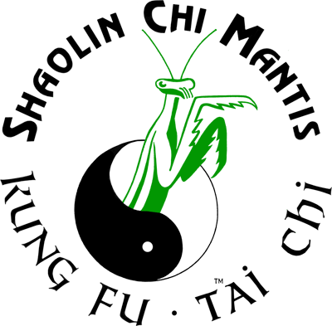
Shaolin Chi Mantis
Scholarship Application

Name:______________________________ Birthdate:_____________ Sex:_______
Address:______________________________________________________________________
Email Address:________________________________ Phone:__________________________
Married:____ Single:____ Children:_____ (ages ____ to ____)
Health Considerations:____________________________________________________________
Bone Breaks:___________________________________________________________________
Any Knee Problems:_____________________________________________________________
Diabetes:______ Heart Problems:______ Torn Ligaments:______________________________
Back Problems:_________________________________________________________________
Medications Prescribed:___________________________________________________________
Some of the above conditions may affect your SCM Scholarship Application but not prevent you from enrolling in Buddha Kung Fu or Tai Chi Youth. This is an athletic program for athletes who have the time to commit to three classes per week and practicing three other days each week. Consider yourself an 'Olympic Athlete' for this program. Eating and sleeping well required. No sparring is allowed at all during this entire program. Review ALL documents before applying.
Previous Martial Arts Training:
Martial Arts School | School Location | Martial Arts Master | Highest Rank Received
What do you want to accomplish with your Shaolin Kung Fu training?
What other physical / mental / spiritual goals do you have?
Trial Period: September 2017 to December 2017. Graduates: January 2018 to December 2018.

Signed:__________________________ Print Name:____________________ Date:___/___/____

